**Realtime Chat App**

**Liberty IT**

**User Manual**

Contents

1. Introduction 1

2. Getting Started 1

3. Run the Application 2

4. Create Database in Chat Application 3

5. Account Setup 3

6.User Interface 5

6.1 Contacts 5

6.2 Chat Windows 5

7. Chatting 5

7.1 Sending Messages 5

8.Notifications 6

9.Privacy and Security 6

10.Contact Support 6

# 1. Introduction

Welcome to the chat app user manual! This manual will guide you through using our chat application to connect with the IT Department and employees. Whether you're new to the app or just looking for some tips, you'll find everything you need to know here

# 2. Getting Started

To start using the chat application, follow these steps:

1. Visit the official website Wamp or xampp for your platform (,Windows, or macOS)
2. Download and install the application.
3. Launch the app once the installation is complete.
4. 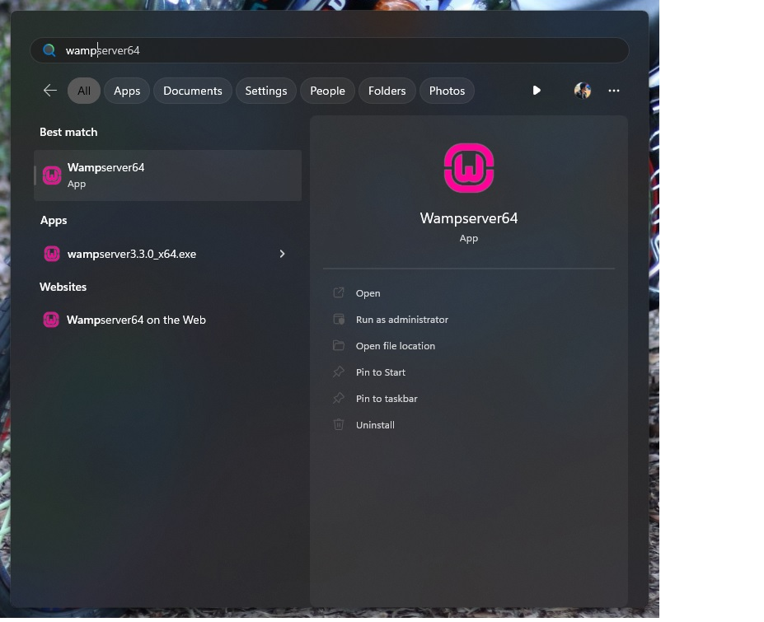Run the server

Figure 1 Run server

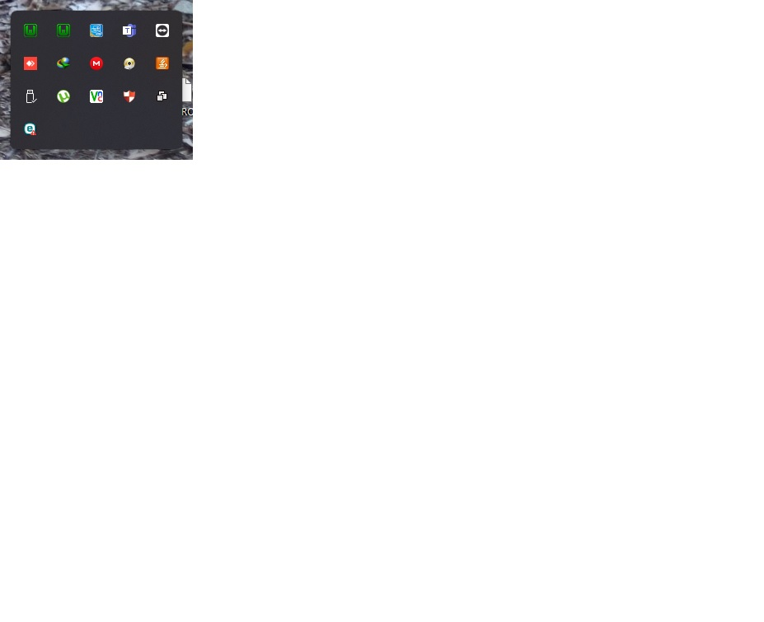

Figure 2 server check

# 3. Run the Application

To start running the chat application, follow these steps:

1. Copy the chatapp folder in the wamp64 www folder
2. Open the any Browser
3. Run the <http://localhost/phpmyadmin/> URL
4. Loading the PHP Admin interface
5. Enter the Login username: root and Click the Login Button

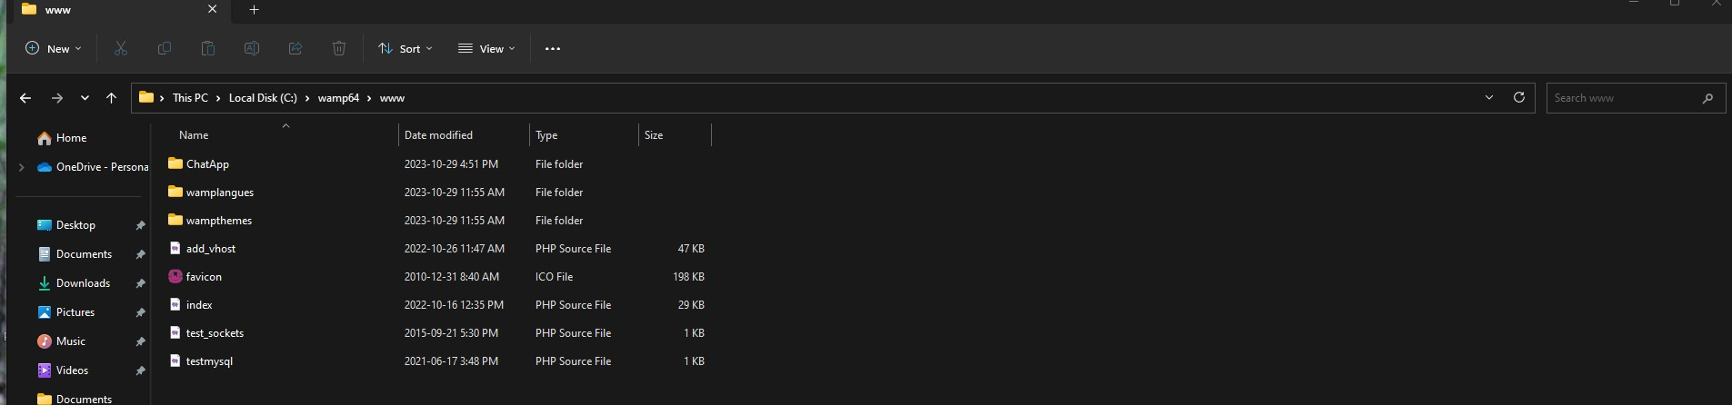

Figure 3 copy chatapp folder

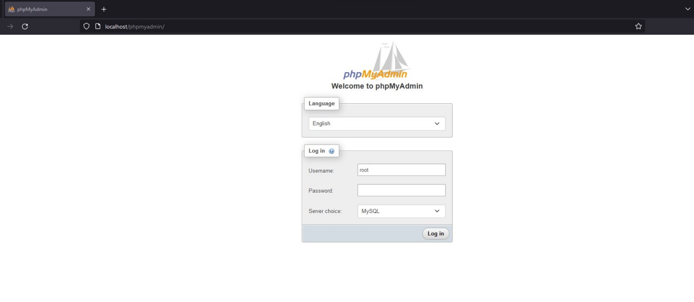

Figure 4 PHP Admin login interface

# 4. Create Database in Chat Application

To start create database the chat application, follow these steps:

1. Click the New tab and enter the chatapp of the database name and create it
2. Create the two table under the chatapp database
3. messages
4. users
5. Create those rows under the two tables

|  |  |
| --- | --- |
| messages | users |
| msg_id int(11) | user_id int(11) |
| incoming_msg_id int(255) | unique_id int(255) |
| outgoing_msg_id int(255) | fname varchar(255 |
| msg varchar(1000) | lname varchar(255 |
|  | email varchar(255 |
|  | password varchar(255 |
|  | img varchar(255 |
|  | status varchar(255 |

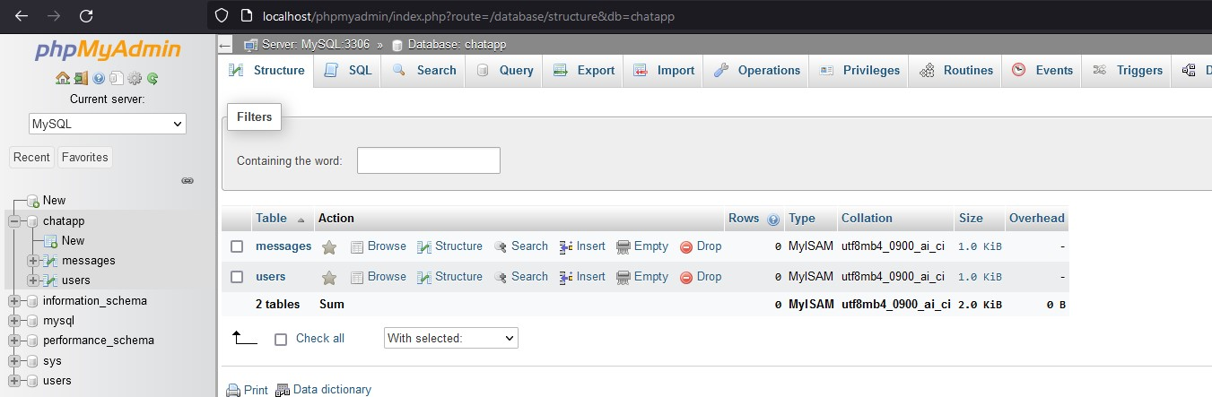

Figure 5 Data base & tables

# 5. Account Setup

Upon first launch, you'll need to set up your account:

1. Open the <http://localhost/chatapp/index.php> URL
2. Click on "Fill the Account" or "Sign Up."
3. Provide your email address or phone number.
4. Create a secure password.
5. Follow the on-screen instructions to complete the registration.

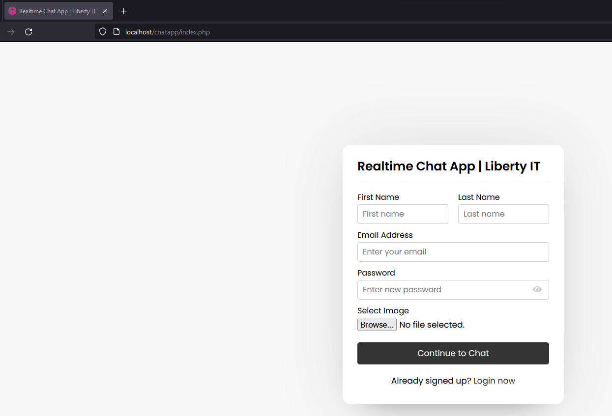

Figure 6 Interface of Account setup

1. Do you have Already Account Click the Login now Button
2. 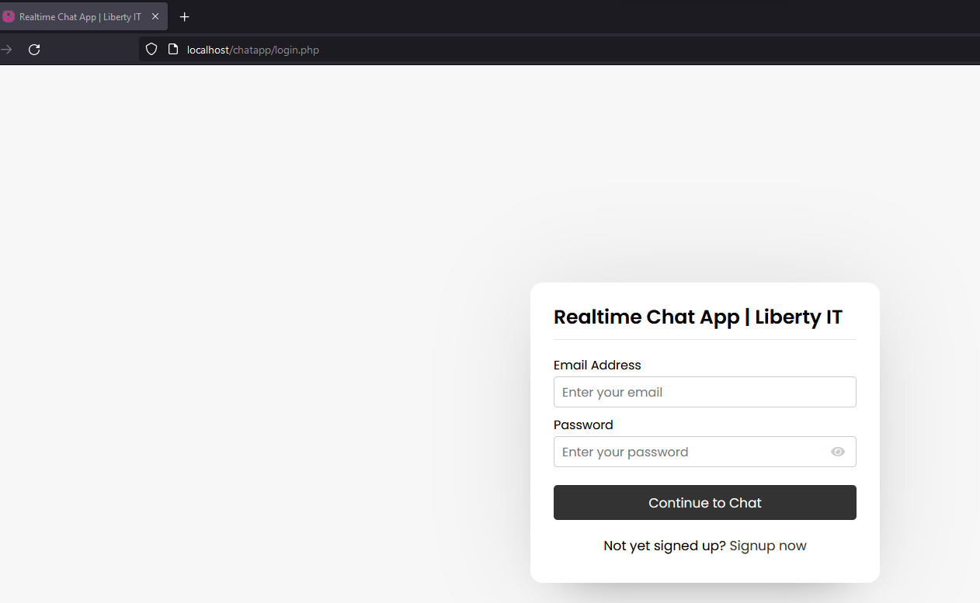Fill the Details

Figure 7

Already have

Account

# 6.User Interface

## 6.1 Contacts

Contacts allow you to find and connect with your IT Department and colleagues. You can add contacts by searching for their username.

## 6.2 Chat Windows

When you open a chat, you'll find the chat window where you can send and receive messages. You can also see the chat history.

# 7. Chatting

## 7.1 Sending Messages

To send a message:

1.Click on a chat to open it.

2.Type your message in the text input field.

3.Press the send button (usually a paper plane icon) to send your message.

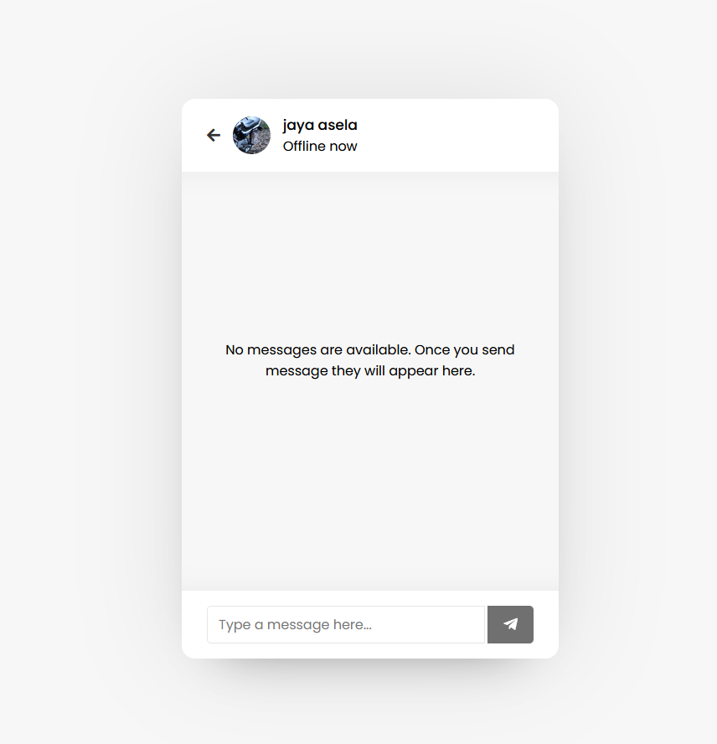

Figure 7 chat Interface

# 8.Notifications

The app will notify you about new messages and updates. You can customize notification settings in the app's settings menu.

# 9.Privacy and Security

Your privacy and security are important. The app employs encryption to protect your data. Check the privacy settings and use strong passwords to enhance your security.

# 10.Contact Support

If you can't find answers in the FAQ or troubleshooting sections, don't hesitate to contact IT team for assistance.